**How to Set Up Java Environment System Variable/Path on Windows**

After you’ve installed the Java Environment Kit (JDK) in Windows, you must set the **JAVA_HOME** **environment variable** to point to the JDK installation directory.

**Setting the JAVA_HOME Variable**

**Step 1)** Open the **Control Panel -> System or Security –> System**; the same thing can be done by **right-clicking** on ‘**MyComputer’**and choosing **Properties.**

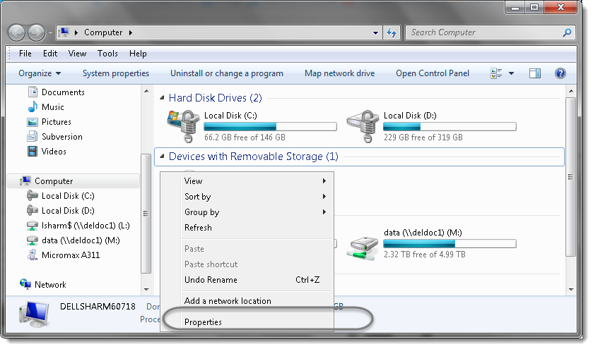

**Step 2)** Choose ‘**Advanced system settings**‘.

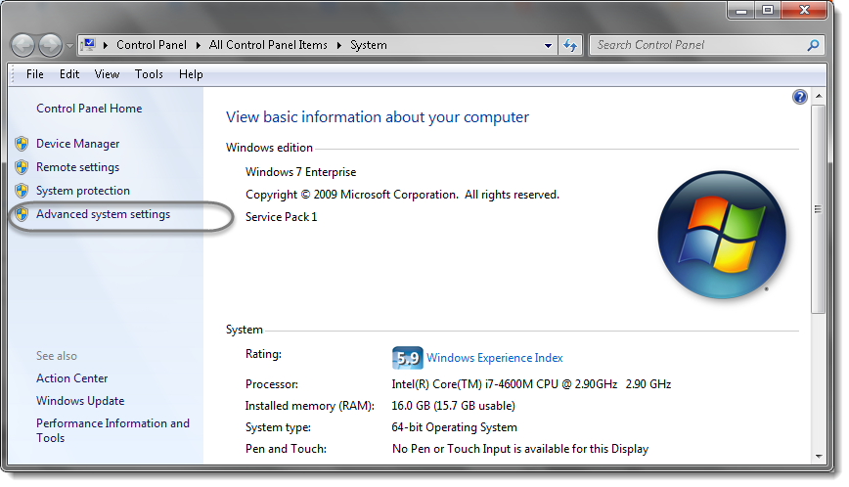

**Step 3)** Under the **Advanced** tab Choose the ‘**Environment Variable…**‘ option.

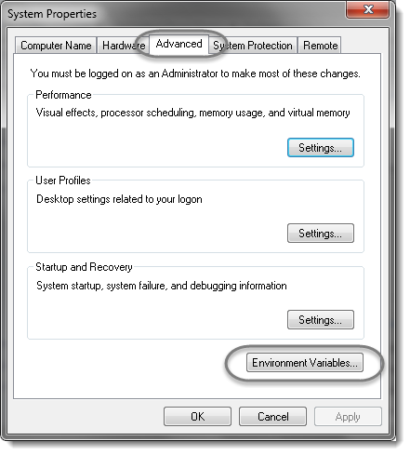

**Step 4)** Select **New** In the **System variables.**

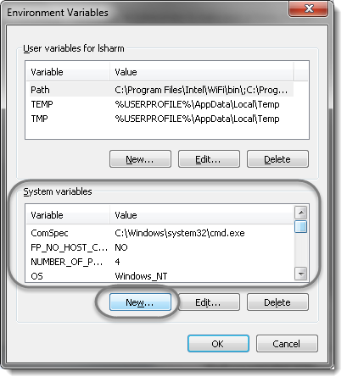

**Step 5)** Define the Variable name as ‘**JAVA_HOME**‘ and Variable value as ‘**C:\Program Files\Java\jdk1.8.0_45**‘ (Modify this value to reflect the real location).

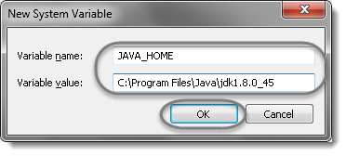

**Setting the PATH Variable**

**Step 1)** Now we need to specify the location in the **PATH** variable, select it and choose the **Edit** option.

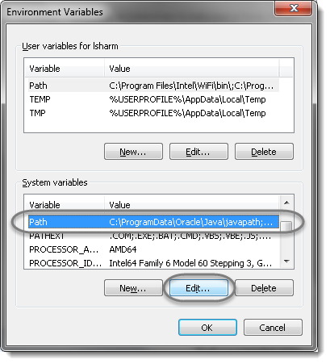

**Step 2)** In the editor add the value ‘**;%JAVA_HOME%\bin**‘ or ‘**;C:Program Files\Java\jdk1.8.0_45\bin**‘.

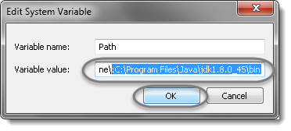

**Note**: The new values are separated by a semicolon from the existing ones and be careful and do not make any changes in the existing string, as it is a very sensitive information.

**Step 3)** Now go to **Start** and type **cmd**in the **Run** and hit **Enter**. It will launch the Command Prompt. Type ‘**java -version**‘, it will display the following information.

